“In Pursuit of Technical Excellence”
[NAME OF THE PROJECT/DISSERTATION/THESIS]
A Report/Dissertation/Thesis
Submitted in partial fulfilment of
the requirements for the award of the degree of

B.Tech / M.Tech / PhD

IN

Name of the Branch
By
NAME OF CANDIDATE(s)
Under the Guidance of
Name of the Guide
Department of Computer Science and Engineering
Government College of Engineering, Aurangabad
Chhatrapati Sambhajinagar


Department of ______________________________
Government College of Engineering Aurangabad, Chhatrapati Sambhajinagar
Month-Year

INDEX/CONTENT
DECLARATION

CERTIFICATE
ACKNOWLEDGEMENTS

ABSTRACT
- Index/Contents/Intent
- List of Abbreviations
- List of Figures/Graphs
- List of Tables

- INTRODUCTION…………………………………………………………..01
- LITERATURE SURVEY…………………………………………………...02
- SYSTEM DEVELOPMENT……………………………………………….03
- PERFORMANCE ANALYSIS…………………………………………….04
- CONCLUSIONS
- References
- Appendices
- Acknowledgement

Chapter

1. INTRODUCTION (5-10 Pages)
- Introduction(Title case)
- Necessity
1.2.1(Introduction of computer systems)
1.2.2
- Motivation
- Objectives
- Contribution/Themes
- Organization

2. LITERATURE SURVEY(15-50 Pages)
Related information available in standard Books, Journals, Transactions, Internet Websites, etc. up to date. (More emphasis on the last three to five years)

3. SYSTEM DEVELOPMENT (15-50 Pages)
3.1 Model Development
3.1.1 Model development
3.2 Analytical
3.3 Computational
3.4 Experimental
3.5 Mathematical
3.6 Statistical
(Out of the above methods, at least one method is to be used for the model development)
Some mathematical treatment or related information is required

4. PERFORMANCE ANALYSIS(25-50 Pages)
4.1 Analysis of the system developed either by at least two methods, depending upon the depth of the standard
4.2 These methods are normally used are Analytical /Computational/Statistical/Experimental/ or Mathematical
4.3 Results at various stages may be compared with various inputs
4.4 Output at various stages with the same waveforms or signals or related information/parameters
- Comparison of the above results by at least two methods
- justification for the differences or error

5. CONCLUSIONS (1-3 Pages)
- Conclusions
- Future Scope
- Applications/Utility

Contributions (if any, 1 Page)
The innovative work/invention/new ideas generated from the analysis of the work can be taken from the conclusions. If possible, a patent may be filed depending upon the level of research or contributory work.

References
- Author, “Title”, Name of Journal/Transactions/ Book, Edition/Volume, Publisher, Year of Publication, pp.__.
- These references must be reflected in the text at appropriate places in square brackets.
- In case of web pages complete web page address with the assessment date has to be listed.
- List of references should be as per use in the text of the report.

Appendices (1-25 Pages)
Related data or specifications or referred charts, details computer code/program, etc.

Acknowledgement (1 Page)
Expression of gratitude and thankfulness for helping in the completion of the said task with the name and signed by the candidate.

General Guidelines
Text should be printed on the front and correct side of the watermark on quality bond paper
Element | Specification
Paper size | A4, 75 to 85 gsm paper
Left Margin | 1.5”
Right Margin | 1/2”
Top Margin | 1”
Bottom Margin | 1”
Text Width | 6”

Page Numbers
- The first page of the first chapter need not be printed anywhere
- Second page onwards at the right-hand corner at ½ inch from the right and the top side
- From the second chapter onwards starting page number of the chapter should be printed at the bottom center place
- Undergraduate report total pages –around 70-100
- Postgraduate Dissertation total pages –around 80-150
- Ph. D. Thesis total pages –around 100-250

Language
- Follow American English. e.g., Fulfilment, Traveling, Meter.
- Preferably use ‘LATEX’ software for writing.
- All Greek words must be italicized, for example e. g., etc., i.e., et al.

General Attributes
Element | Formatting
Report Heading | ALL CAPS, 16 Font
Chapter Heading | ALL CAPS, 14 Font
Subchapter | Title Case, 12 Font
Sub-Subchapter | First Alphabet Capital, 12 Font
Page Numbers | Roman numerals for Index/Contents/Intent
Report Title | Max two lines
Text Pages | Times New Roman
The page of the Index/Contents/Intent heading should be below the words for the appropriate sub-chapter or sub-sub-chapter chapter as shown in the sample copy
Cover page should have (Mission statement of Institute) in inverted commas, Symbol of Institute, Name of Department, and Institute

Inclusion
Ph. D. Thesis should contain the pages in the following regard
- Abstract, Synopsis, and Statement of originality at the start
- Summary sheet followed by contributions
- List of related publications
- Minimum number of pages PhD Project Report is 150-200
M. Tech. Dissertation should contain the pages in the following regard
- Certificate, Statement of originality, followed by Abstract
- Dissertation approval sheet
- List of related publications
- Minimum number of pages PG Project Report is 100-150

B.Tech. Project Report should contain the pages in the following regard
- Certificate, Statement of originality, followed by Abstract.
- Minimum number of pages UG Project Report is 80-120

Binding
- Black color, golden screen printed or embossed
- The width of the report should have a front side degree-B. Tech. /M. Tech. /Ph. D. with appropriate branch in bracket
- Central place for Title and lower place for year of submission [B. Tech. ]
- Central place for the name of Student/Research Scholar [M. Tech. /Ph. D. ]

Flap
Suitable flap with the name of the candidate, the Department and Institute name, and symbol can be used with a nylon strip

Sample (Side)
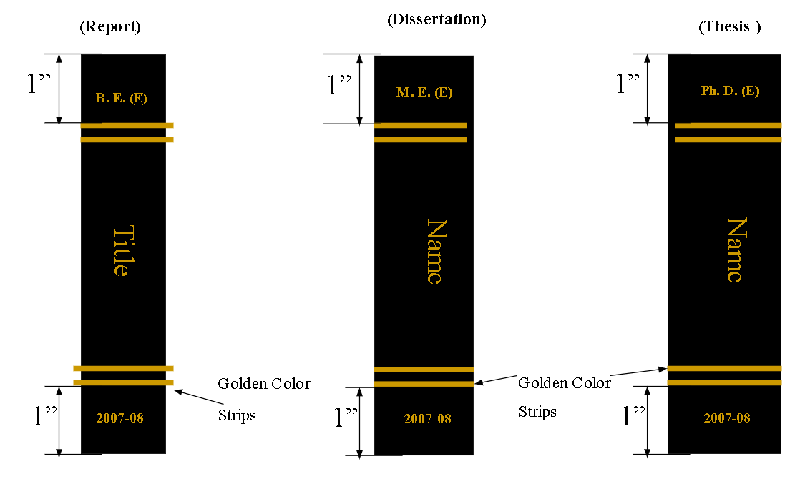

Sample (Cover)
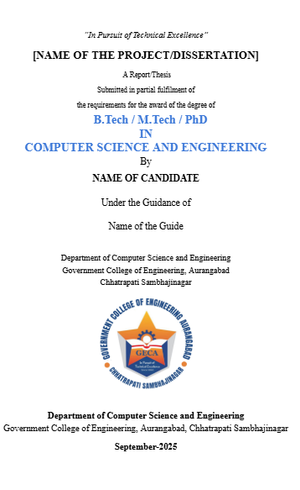

Sample (Certificate)
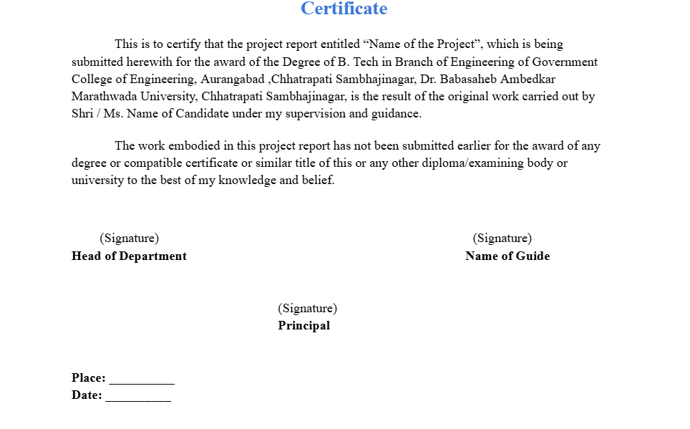

Sample (Declaration/ Statement of Originality)


